Chapter 8 Momentum and force

Chapter test Total marks 48

Name: ______________________________ Class: ____________ Date: _______________

Section A (1 mark per question)

Question 1

A 40 kg child on a scooter is rolling down a footpath at 2.5 m s–1. Which of the following options correctly gives the momentum of the child?

A 16 kg m s–1 down the footpath

B 100 kg m s–1 down the footpath

C 0.40 kg m s–1 down the footpath

D 42.5 kg m s–1 down the footpath

Question 2

Which of the follow options is the law of conservation of momentum?

A The product of the momentum before a collision is equal to the product of the momentum after it.

B The product of the momentum before a collision is always greater than the product of the momentum after it.

C The sum of the momentum before a collision is equal to the sum of the momentum after it.

D Momentum can neither be created nor destroyed; it can only change form.

Question 3

In an explosive collision, a cannon and a cannonball are initially at rest. Which of the following options can we *not* be certain about?

A After the collision the momentum of the cannonball added to the momentum of the cannon will equal zero.

B The cannonball and the cannon will be moving in the same direction as each other.

C The cannonball will be moving faster than the cannon.

D The momentum of the cannonball and cannon before the collision is zero.

Question 4

A 1500 kg vehicle is travelling at 20 m s–1. What average net force would be needed to stop the vehicle in 4.0 s?

A 1.5 × 104 N

B 5.0 N

C 7.5 × 103 N

D 260 N

*The following information applies to questions 5–7.*

The graph shows how a force applied to an initially stationary 5.0 kg bowling ball varied with time.

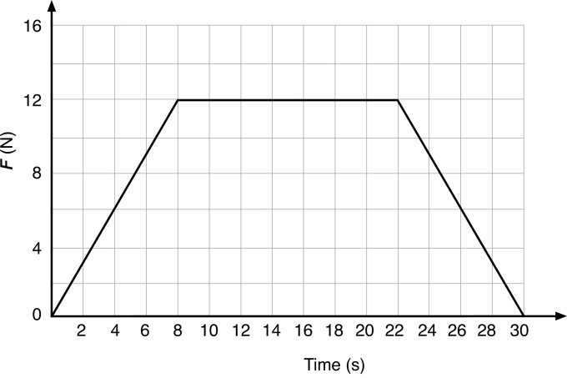

Question 5

What was the total impulse exerted on the bowling ball over the 30 s?

A 456 Ns

B 336 Ns

C 264 Ns

D 168 Ns

Question 6

What was the change in momentum of the bowling ball?

A 456 kg m s–1

B 336 kg m s–1

C 264 kg m s–1

D 168 kg m s–1

Question 7

What was the final speed of the bowling ball?

A 12.0 m s–1

B 24.0 m s–1

C 36.8 m s–1

D 52.8 m s–1

Question 8

A car is travelling north along a road at 8 m s–1. The car turns a corner and keeps travelling at 8 m s–1 now travelling towards the west. Which of the following options is correct?

A The momentum of the car has changed.

B The speed of the car has changed.

C The velocity has not changed.

D The momentum of the car has not changed.

Question 9

If an object is moving with a constant velocity then according to Newton’s first law which of the following is correct?

A It will continue with this velocity only if a net external unbalanced force acts.

B It will change its velocity if a net unbalanced external force is applied.

C It will continue with its velocity as no external unbalanced force acts.

D It will continue with its velocity as friction only acts if an external unbalanced force is applied.

Question 10

A 10 tonne truck collides with an unoccupied and stationary Mini. According to Newton’s third law, which of the following is correct?

A The truck applies the same magnitude force to the Mini as the Mini applies to the truck.

B The truck applies a greater magnitude force to the Mini than the Mini applies to the truck.

C The truck applies a smaller magnitude force to the Mini than the Mini applies to the truck.

D The truck applies the force to the Mini while the Mini applies no force to the truck.

Section B

Question 11

A 0.5 kg ball is thrown horizontally west at a wall with a speed of 20 m s–1. It rebounds horizontally at 13 m s–1 east. What is the change in momentum of the ball? (2 marks)

Question 12

A high-velocity 8.10 g rifle bullet, travelling horizontally, lodges in a 2.00 kg wooden block, at rest on a horizontal, frictionless plane. The block, with the bullet stuck inside, reaches a velocity of 7.00 m s–1 in the same direction as the bullet.

a Find the impact velocity of the bullet. (2 marks)

b Calculate the impulse on the block. (2 marks)

Question 13

A physics student studies the car she has just bought to get to university each day. The car has a mass of 945 kg, can go from 0 to 60.0 km h-1 in 6.50 s, and is painted bright yellow.

a Calculate the acceleration of the car. (2 marks)

b Calculate the force causing the car to accelerate. (2 marks)

c Calculate the weight of the car. (2 marks)

d While she is in class a 5.00 tonne truck collides with her stationary car, which is parked on the side of the road. On the diagram below, use labelled vector arrows to accurately show the forces acting on the truck and on the car. (3 marks)

Question 14

Speedway programmes often include an event called a ‘Demolition Derby’. In this event, the cars, which are usually older models of conventional makes, race each other, and the drivers can deliberately collide their cars. Mad-Emily’s car of mass 1.20 × 103 kg, travelling at 60.0 km h–1, collides head on with Crazy-Clare’s car of mass 2.00 × 103 kg, which is also travelling at a speed of 60.0 km h–1 but in the opposite direction.

a Compare the forces experienced by each car during the collision (no calculation required). Explain your reasoning in terms of Newton's laws. (2 marks)

b If the two cars are in contact for 0.01 s during the collision, compare the impulse experienced by both cars (no calculation required). Explain your reasoning. (2 marks)

c In such a potentially dangerous event, what safety features do drivers include in their cars to protect them in the inevitable collisions? (2 marks)

Question 15

A 35.0 kg girl is jumping on a trampoline. She is travelling at 6.00 m s–1 when she hits the trampoline at 45° to the horizontal travelling to the right and bounces back up with a velocity of 4.20 m s–1 at 45° to the horizontal travelling to the right. Calculate:

a the initial momentum of the girl (1 mark)

b the change in momentum of the girl. Use north, south, east and west to designate direction, where N–S are up–down respectively, and E–W are right–left. (3 marks)

Question 16

A witness to a traffic accident reported that she observed a collision between a red car travelling north towards an intersection and a blue car of similar mass, travelling west. She estimated that before the collision the speed of the red car was approximately 45 km h–1 and the speed of the blue car was 80 km h–1. The police measured the accident scene and found that both cars had locked together and had come to rest at a position 62° west of north (N 62° W) from the impact point.

**a** Calculate the approximate momentum of each car *before* the collision. (2 marks)

**b** Calculate the total approximate momentum—i.e. the sum of the two momenta—*before* the collision. (3 marks)

**c** How does the direction of this total approximate momentum compare to the direction in which the cars came to rest? (2 marks)

**d** Comment on the claims made by the witness. (2 marks)

Question 17

Car safety for drivers has been improved with the introduction of airbags. Explain, with reference to the following concepts, why this is so.

a Newton’s first law of motion (2 marks)

b impulse (2 marks)